SUBMISSION OF A REQUEST FOR A REFUND OF EXCISE DUTY FOR GAS OIL USED AS ENGINE FUEL FOR COMMERCIAL TRANSPORT
(form TRO-K)
IN ELECTRONIC FORM USING THE E-TROD INFORMATION SYSTEM

In line with Article 20.a of Slovenian Excise Duty Act (Official Journal of the RS, no. 47/16, 92/21 and 192/21 – unofficial consolidated text) all persons carrying out a business activity in RS are obliged to request a refund of excise duty in electronic form through the information system of the tax authority. Companies established in EU/EFTA countries can be exempted from this rule only if they have not yet obtained a tax identification number in Slovenia or if the information system of the tax authority does not work and a fall-back procedure is used. In this case they can request a refund of excise duty in paper form.

To obtain the concerned tax identification number the required information and forms in English are available on the following site Obtaining a tax identification number for a foreign company. The application for entry of foreign legal persons in the tax register (DR-04 form) has to be submitted electronically through FURS's eDavki service as their own document, in person or by post, to any finance office (except to the Special Financial Office and the General Finance Office).

INSTRUCTIONS FOR USERS WHO ENTER THE eDavki PORTAL WITH A QUALIFIED DIGITAL CERTIFICATE

The amendment to the Excise Duties Act stipulates a change in the method of submitting the Request for a refund of excise duty. From 1 January 2022, the mandatory submission of all excise duty refund applications in electronic form via the E-TROD information system (hereinafter IS E-TROD) is introduced. IS E-TROD is located on the eCarina portal. Users access the eCarina portal via the eDavki portal .

In order to successfully submit a TRO-K request/form via IS E-TROD Edge, Chrome or Firefox internet browser should be used.

- REGISTRATION OF A QUALIFIED DIGITAL CERTIFICATE IN THE eDavki PORTAL

New users of the eDavki portal, who will access the eDavki portal with a qualified digital certificate, must complete the registration procedure before the first login to eDavki. By registering a digital certificate in the eDavki portal, your registration data is automatically transferred to the eCarina portal, thus enabling you to access the IS E-TROD.

Step One: Obtain the appropriate digital certificate for the user

To access the secure eDavki portal, you must first obtain the appropriate digital certificate. If you do not already have a digital certificate, obtain it from one of the authorized certifiers. Install it according to their instructions. Only qualified digital certificates from one of the following digital certificate authorities may be used for this purpose:
- SIGOV-CA (www.sigov-ca.gov.si),
- SIGEN-CA (www.sigen-ca.si),
- POŠTA®CA (http://postarca.posta.si),
- HALCOM-CA (www.halcom.si).

Information regarding the acquisition of qualified digital certificates, their types and purposes of use is published on the websites of certification service providers.
Second step: Registration of the digital certificate of the new user in the eDavki portal

To register a qualified digital certificate before using it for the first time on the eDavki portal, select the "Registration using digital certificate" button on the entry page of the eDavki portal (Figure 1).

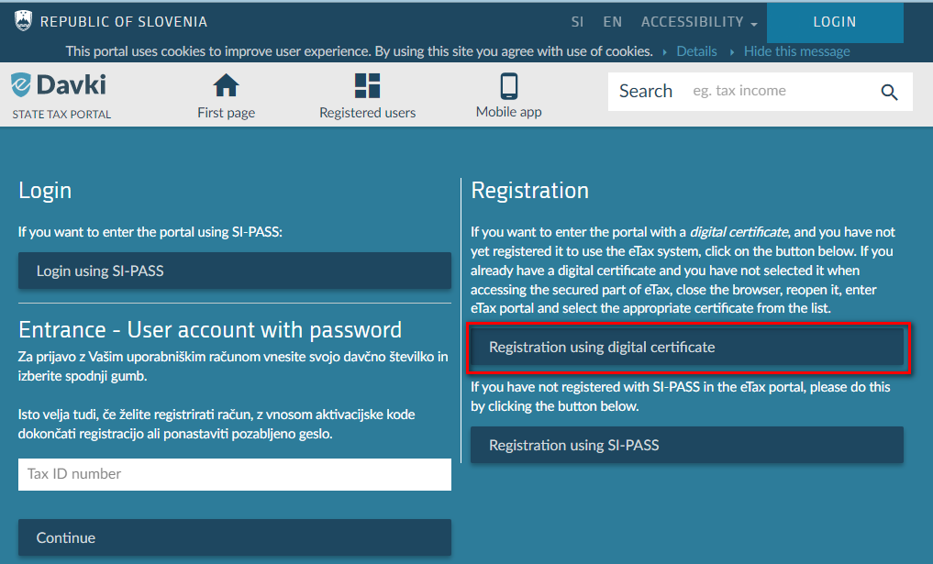
Figure 1: Entry page of the eDavki portal
After selecting the "Registration with a digital certificate" button, the "First registration" window will open, where detailed instructions regarding registration and the first login are written. To complete the qualified digital certificate registration, select the "First registration" button (Figure 2).

After the first login, you will be able to automatically enter the eCarina system and thus access the IS E-TROD.

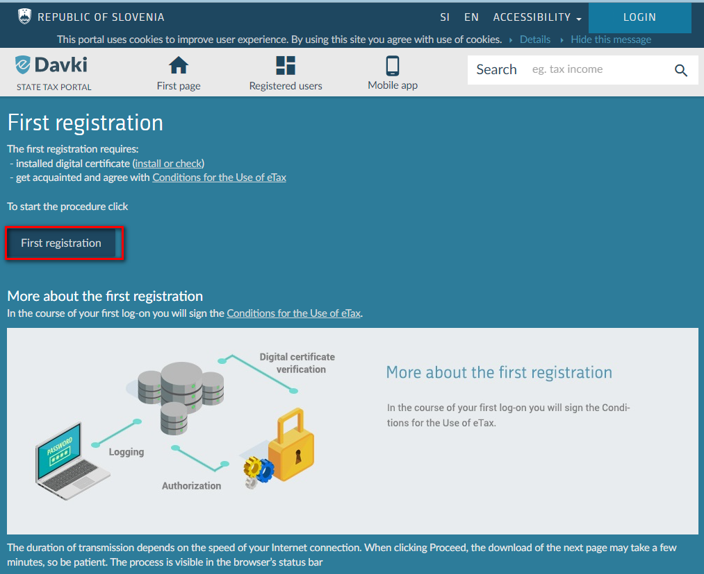
Figure 2: The window where the first registration is made on the eDavki portal

Third step: Signing documents in IS E-TROD

If you are going to enter the eDavki portal with a qualified digital certificate, you must install the appropriate signature component ProXSign in order to successfully sign and submit documents.

- REGISTRATION IN THE eDavki PORTAL WITH A QUALIFIED DIGITAL CERTIFICATE

To log in to the eDavki portal with a qualified digital certificate, select the "LOGIN" button, which is located in the upper right corner of the eDavki portal (Figure 3).

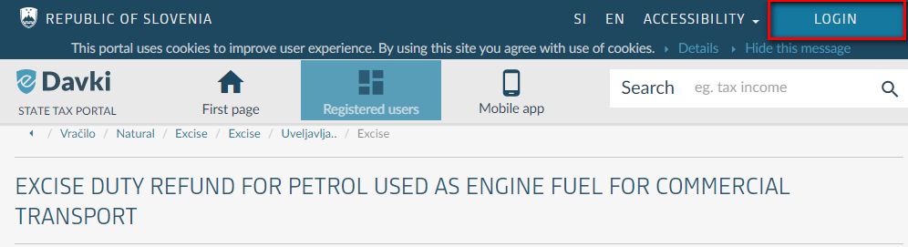
Figure 3: Login to the eDavki portal with a qualified digital certificate

- ACCESS TO THE TRO-K REQUEST/FORM THROUGH THE eDavki PORTAL

After logging in to the eDavki portal, you access the TRO-K request form via the first page of the portal, where you first select the "Natural persons with an activity" section (Figure 4), and then the "Excise duties and environmental fees" section (Figure 5).

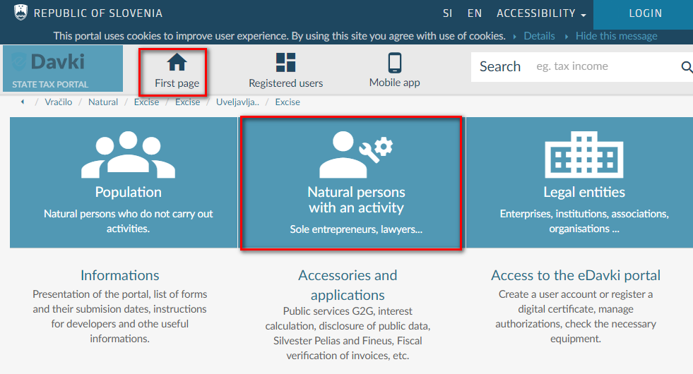
Figure 4: First page of the portal eDavki

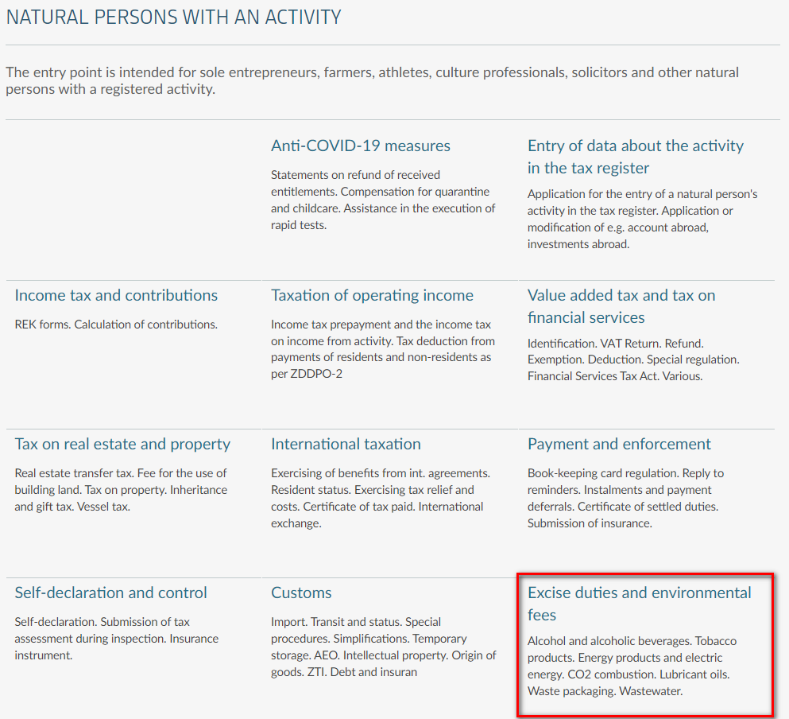
Figure 5: Areas within the field »»Natural persons with an activity« on the eDavki portal
In the field "Excise duties", "Excise duty refunds" select the field "Excise duty refund for petrol used as engine fuel for commercial transport" (Figure 6).

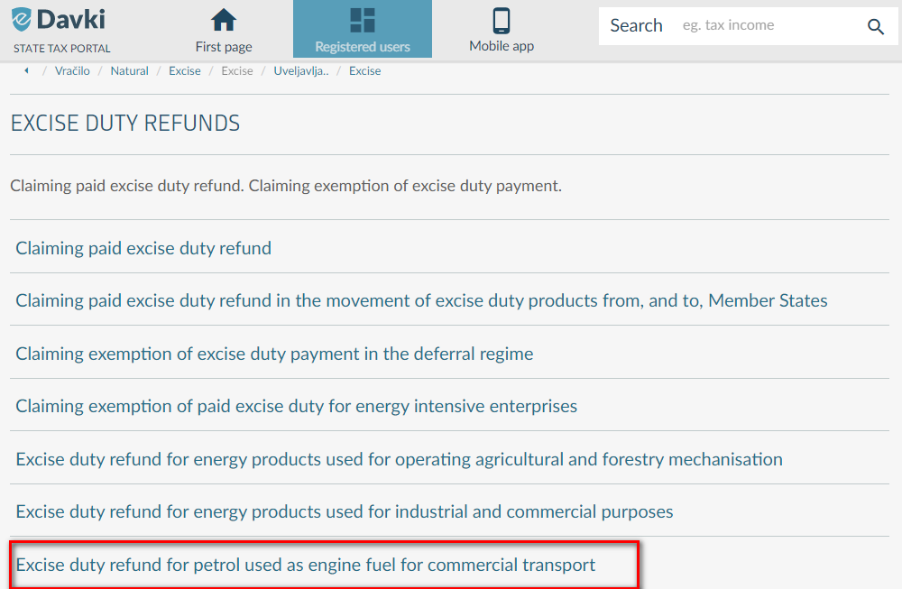
Figure 6: Documents within the field of "Excise duty refunds" on the eDavki portal

Continue the process by selecting the "Electronic submission" button (Figure 7), which can be found in the description of the request "Request for a refund of excise duty for gas oil used as a propellant for commercial purposes".

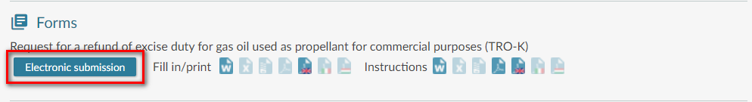
Figure 7: Description of the request "Request for a refund of excise duty for gas oil used as a propellant for commercial purposes" on the eDavki portal

Selecting the "Electronic submission" button will redirect you to the eCarina portal, where you then select the "Prijava preko e-Davkov" button (Figure 8), which will take you to the eCarina portal, where you select the E-TROD tab (Figure 9).
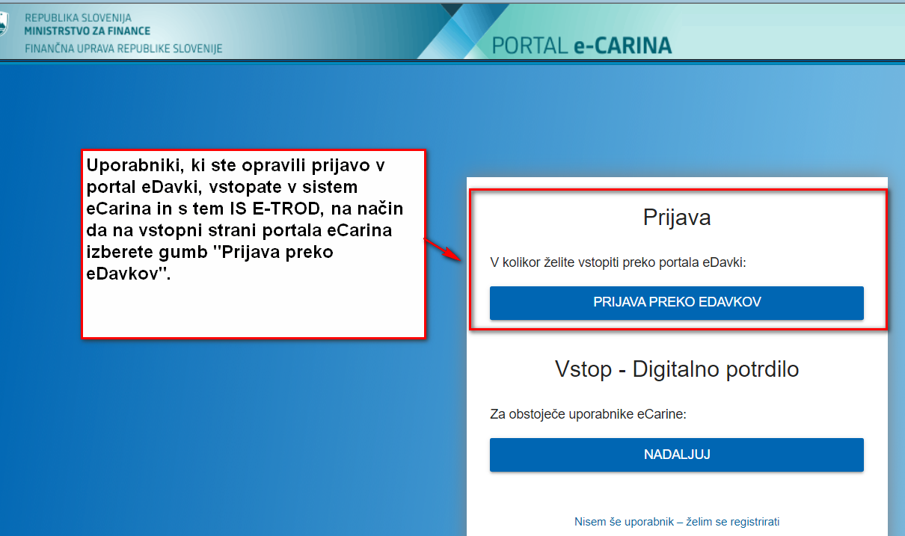
Figure 8: Entry page to the e-Carina portal

- PROCEDURE FOR PREPARATION AND SUBMISSION OF TRO-K REQUEST IN ELECTRONIC FORM THROUGH IS E-TROD

You start the process of creating a TRO-K request in IS E-TROD on the "Vračila" component and the "Predložitev dokumentov" submenu by selecting the "Dodaj dokument" button, which opens the "Nov dokument vračila" input screen (Figure 9). From the drop-down list on the input mask, select the form " Zahtevek za vračilo trošarine za plinsko olje, ki se porabi kot pogonsko gorivo za komercialni prevoz (TRO-K)" and specify the period for which you are claiming a refund of excise duty. To continue the process, confirm the selected data by selecting the "Potrdi" button.

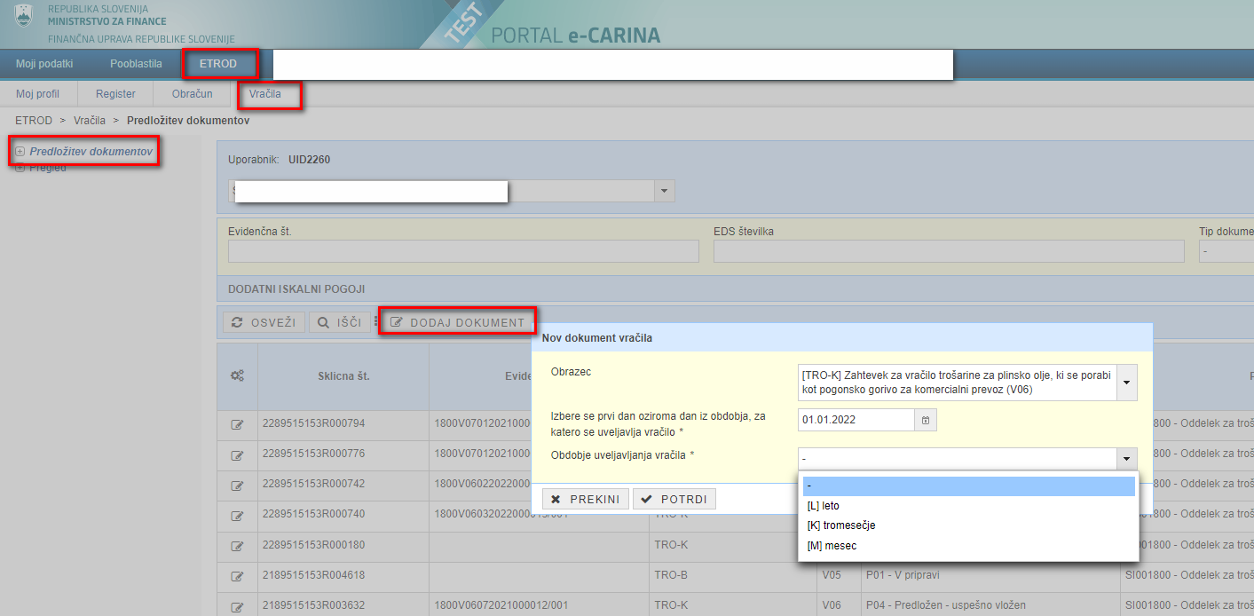
Figure 9: Completion of the form "Request for refund of excise duty on gas oil used as engine fuel for commercial transport (TRO-K)" in IS E-TROD

Based on the selected data on the input mask, a TRO-K request is created, in which you enter:
- Number of invoices for the purchase of gas oil, on the basis of which the refund is claimed;
- contact details;

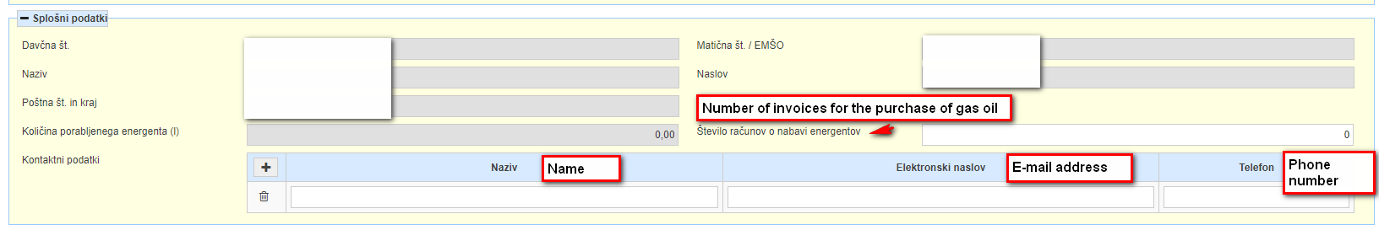
- select a transaction account for excise duty refund from the drop-down list,

- quantity of gas oil used per motor vehicle (for the transport of goods and passengers – in litres) - With regard to the use of gas oil (for transport of goods, transport of passengers), enter the registration numbers of the motor vehicles for which the gas oil was used and the quantity of gas oil used per motor vehicle.
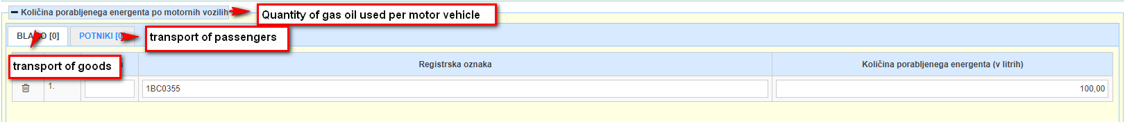

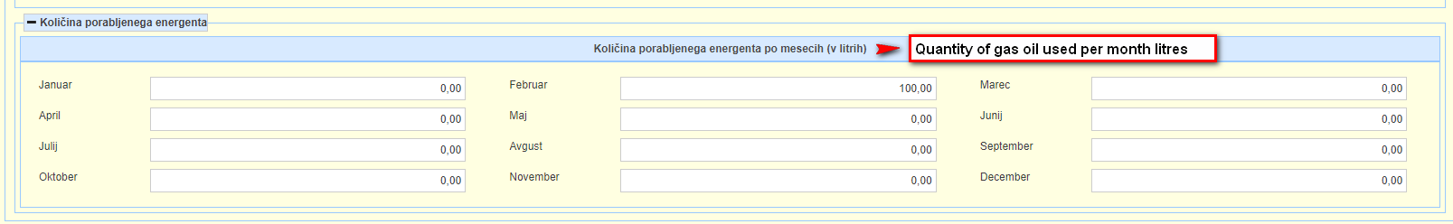
- quantity of gas oil used per month (for the transport of goods and passengers – in litres). With regard to its specific use (for transport of goods, transport of passengers) and the marked calendar period, enter the quantity of the gas oil used in each month, which an excise duty refund is claimed for and which can be proved with invoices. The quantity of the gas oil used per month is entered also when a claim is submitted for a calendar quarter or a calendar year.

- seller of gas oil (total quantity used for the transport of goods and passengers). Enter the tax ID number and the name of the gas oil seller, the type and the quantity of the used gas oil in litres purchased from the mentioned seller.

We recommend that you indicate on the TRO-K request in the section "Potrditev navedenih podatkov / Confirmation of the stated data" (Figure 10) that you want to receive information on the successful submission of the request. In this case, upon successful submission you will be notified of the successful submission to the e-mail address you provided in the contact details set.

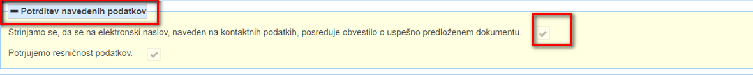
Figure 10: "Potrditev navedenih podatkov" set on the TRO-K request in IS E-TROD

After completing the entry and saving the data, submit the TRO-K request to the Financial Administration by selecting the button »Podpiši in pošlji v potrjevanje« (Figure 11).

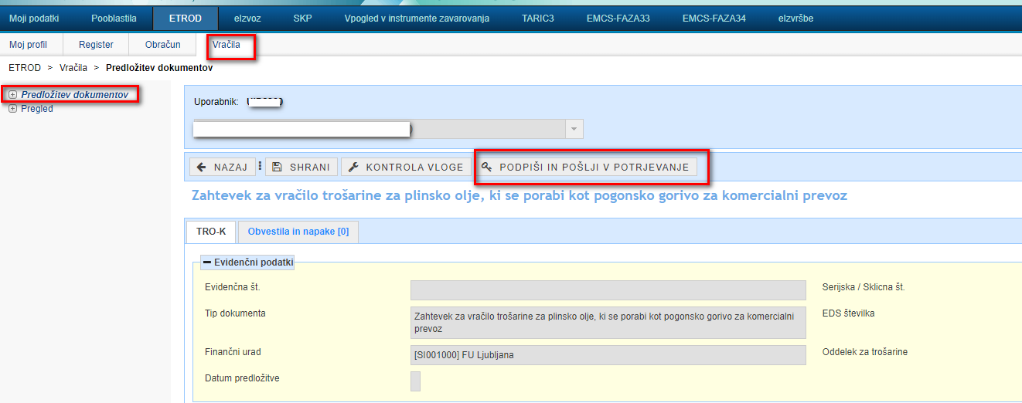
Figure 11: Procedure for submitting a TRO-K request to the E-TROD IS

In the case of correct implementation of the TRO-K request submission procedure and successful processing, the TRO-K request/claim goes into the "Submitted - successfully filed" state (»Predložen-uspešno vložen«), which confirms the correct and successful submission of the claim to the tax authority. The successfully submitted and signed TRO-K request is assigned a document registration number.

The TRO-K request is successfully submitted to the tax authority when it enters the "Predložen-uspešno vložen” – “Submitted-successfully filed" state in the E-TROD IS.

In case of unsuccessful submission or processing of the TRO-K request, the status " Predložen – neuspešno vložen« - “Submitted - unsuccessfully filed" is determined for the request. In this case, you must resubmit the request. In doing so, observe the legal deadlines for submitting a specific request.

- ARRANGEMENT OF ACCESS TO IS E-TROD FOR AUTHORIZED REPRESENTATIVE

The beneficiary for the refund of excise duty can authorize another person (the authorized person/representative) to submit and review claims for refund of excise duty via IS E-TROD at the tax authority on behalf of the beneficiary.

In the authorization, the beneficiary, as the authorizer, appropriately indicates the extent of the authorization of the authorizer regarding actions related to documents in the field of excise duties. The authorization, scanned in PDF format, is sent to the e-mail address mb.fu@gov.si or physically by post to the Financial Office Maribor. After verification of authorization by the tax authority, the authorized person is enabled to enter and review requests for excise duty refund via IS E-TROD. The authorized person enters the system in the manner described in this document in chapter 1. REGISTRATION OF A QUALIFIED DIGITAL CERTIFICATE IN THE eDavki PORTAL.

- HELP DESK / USER SUPPORT:
Sektor za centralno pomoč uporabnikom
Mednarodni prehod 2 b, Vrtojba 5290 Šempeter pri Gorici
T: 05 297 6800
E: sd.fu@gov.si

